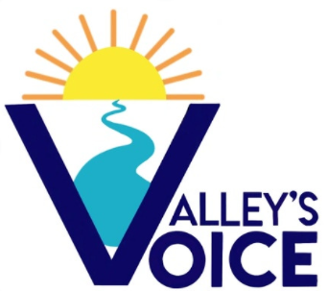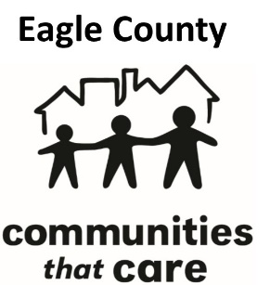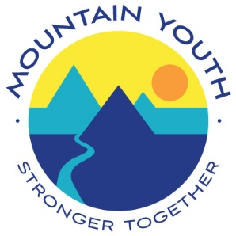

**Permission Slip and Waiver of Liability**

**Participant** *(Please Print): ____________________________* **Age:** _____ **Pronouns:** __________

**Mailing Address:** ____________________________________________________ **School**:__________

**Date of Birth:** _________________ **Phone:** ______________ **Email: _____________________________**

I give my permission for my child ____________________ to participate in all activities related to Mountain Youth’s Valley’s Voice, including but not limited to monthly meetings and community service projects. Activities of Valley’ Voice may involve strenuous physical activity, exposure to changing weather and terrain elements, and hazardous activities that demand the total attention and responsibility of each participant, either as an individual or part of a cooperating group. Your permission, indicated below, acknowledges these risks.

1. I understand that I will be a part-time employee and will be paid by Mountain Youth for my time. If I am in middle school, I will be paid $15 per hour. If I am in high school, I will be paid on a scale ($16, $18, $20 per hour) based on my level of investment in Valley’s Voice. If I am 14 or older, I will be on payroll, need to fill out a w-4 and i-9 form, and receive checks. If I am younger than 14, I will be paid with a Visa gift card every few months.
   1. Yes, I understand *(Guardian and Participant Initials)* _____________
2. I understand that if I am under 14, child labor laws restrict working after 7pm. Mountain Youth meetings, events, etc. may go past this time. I/my child has the option to leave events at any time. Mountain Youth has my/child’s permission to participate past 7pm.
   1. Yes, I understand *(Guardian and Participant Initials)* _________

1. I understand and acknowledge this release discharges Mountain Youth from any liability or claim that I may have against them with respect to bodily injury, personal injury, illness, death, or property damage that may result from my child’s participation in VV.
   1. Yes, I understand *(Guardian and Participant Initials)* ____________

1. I understand my participation in activities is purely voluntary and I elect to participate in spite of the risks.
   1. Yes, I understand *(Guardian and Participant Initials)* ___________

1. In compliance with COVID-19 measures, I understand that if my child is feeling sick, I will keep them home from all VV activities. Meetings are in person, but hybrid learning will be available for those with good reason to not attend in person (sick, etc.)
   1. Yes, I understand *(Guardian and Participant Initials)* ____________

1. In compliance with COVID-19 measures, I agree to wear a face covering if unvaccinated and maintain 6’ of distance from others at all meetings, community events, etc…  Masks are optional for vaccinated individuals. Mountain Youth will follow County health guidelines during all meetings/activities.
   1. Yes, I understand *(Guardian and Participant Initials)* ____________
2. I understand that if school is fully virtual and our county is in the orange or red zone due to COVID-19, all VV and Mountain Youth activities will be held virtually, in order to keep all participants safe.
   1. Yes, I understand *(Guardian and Participant Initials)* _____________________

1. I hereby certify that I am physically fit and Mountain Youth staff members have been informed in writing of any medical conditions or allergies that affect my ability to participate in activities.
   1. Yes, I understand *(Guardian and Participant Initials)* ______________________

1. I hereby freely and expressly assume and accept the responsibility for any and all risks of injury or death while participating in VV activities. I understand that Mountain Youth, its directors, officers, agents, employees, and volunteers (hereinafter “releasees”) do not assume any responsibility for or obligation to provide me with financial or other assistance, including but not limited to medical, health, or disability benefits or insurance of any nature in the event of injury, illness, death or damage to my property. I expressly waive any such claim for compensation or liability on the part of Mountain Youth beyond what may be offered freely by Mountain Youth in the event of such injury or medical expenses incurred by me.
   1. Yes, I understand *(Guardian and Participant Initials)* __________________

1. I agree that in the event of a medical emergency, Mountain Youth, its agents, employees, and volunteers may provide medical assistance deemed necessary under the circumstances. I further agree and authorize Mountain Youth, its agents, employees, and volunteers to make any and all necessary arrangements for emergency care and I agree that these parties shall be free from any liability to me or my heirs for personal injury or loss resulting from my transportation to a medical facility.
   1. Yes, I understand *(Guardian and Participant Initials)* _____________________

1. I grant permission to Mountain Youth to use photographs, video, and audio taken of me for use in publications such as brochures, newsletters, reports and to use such images in electronic versions of the same publications or on websites or other electronic forms or media. I hereby waive any right to inspect or approve the finished photographs or printed or electronic matter that may be used in conjunction with them now or in the future, whether that use is known to me or unknown. I am not entitled to any compensation, payment, or royalties for their use and I understand that all materials will remain the property of Mountain Youth.
   1. Yes, I understand *(Guardian and Participant Initials)* ___________________

1. I expressly agree that this release is intended to be as broad and inclusive as permitted by the laws of the State of Colorado and that this release shall be governed by and interpreted in accordance with the laws of the State of Colorado. I agree that in the event that any clause or provisions of this release is deemed invalid, the enforceability of the remaining provisions of this release shall not be affected.
   1. Yes, I understand *(Guardian and Participant Initials)* ________________

1. By signing below, I express my understanding and intent to enter into this release and waiver of liability willingly and voluntarily.

**Signature** (*Participant*): _______________________________ **Date:** ______________

***Participant under 18 years of age:*** As parent/guardian signing this agreement for the above-named minor, I acknowledge that I am authorized to sign this agreement for the minor. I acknowledge and agree that I have read the above release and that by signing this release on behalf of the minor, the minor and I agree to be bound by its terms. I hereby agree to indemnify, defend and hold harmless the releasees for any claim or suit arising out of said minor’s participation in Valley’s Voice activities.

**Signature** (*Guardian*): __________________________________________ **Date:** ______________

**Emergency Contact:**

In case of an emergency, please contact:

**Name:** _____________________________________ **Phone:** ________________

**Relationship:** ____________________________________ **Alternate Phone:** _____________________